PROGRAM
import cv2
import numpy as np
image = cv2.imread("color_fruits.png")
if image is None:
print("Image not found")
else:
kernel = np.ones((5, 5), np.uint8)
eroded_image = cv2.erode(image, kernel, iterations=1)

cv2.imshow("Original Image", image)
cv2.imshow("Eroded Image", eroded_image)

cv2.waitKey(0)
cv2.destroyAllWindows()
COMMANDS USED
cd Desktop
cd opencv
python image_erosion.py
INPUT
The input image used in this experiment is color_fruits.png, which contains fruits with different colors.
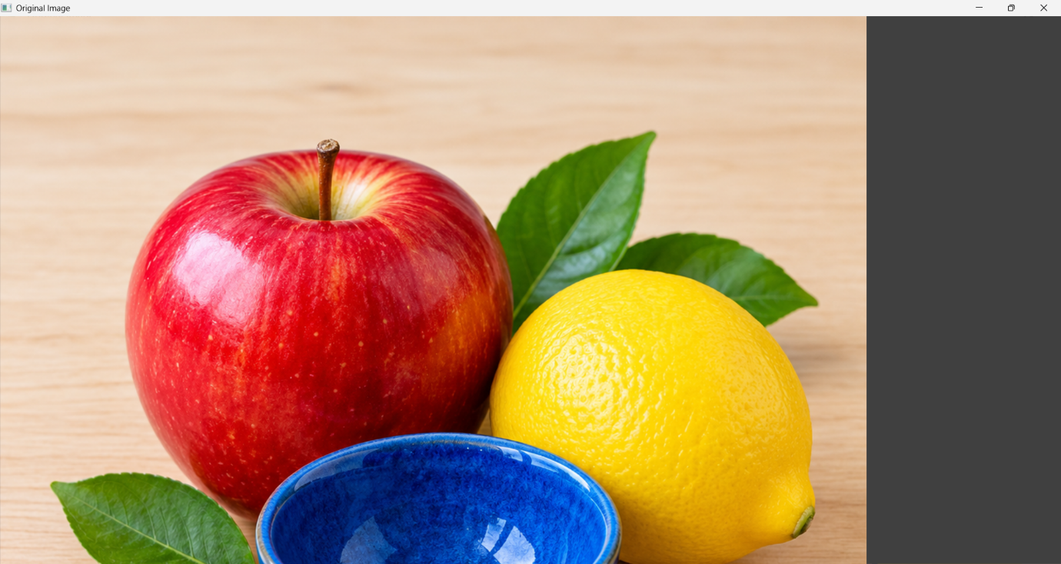
OUTPUT
The original image and the eroded image are displayed. The erosion operation reduces the size of foreground regions and makes their boundaries smaller.
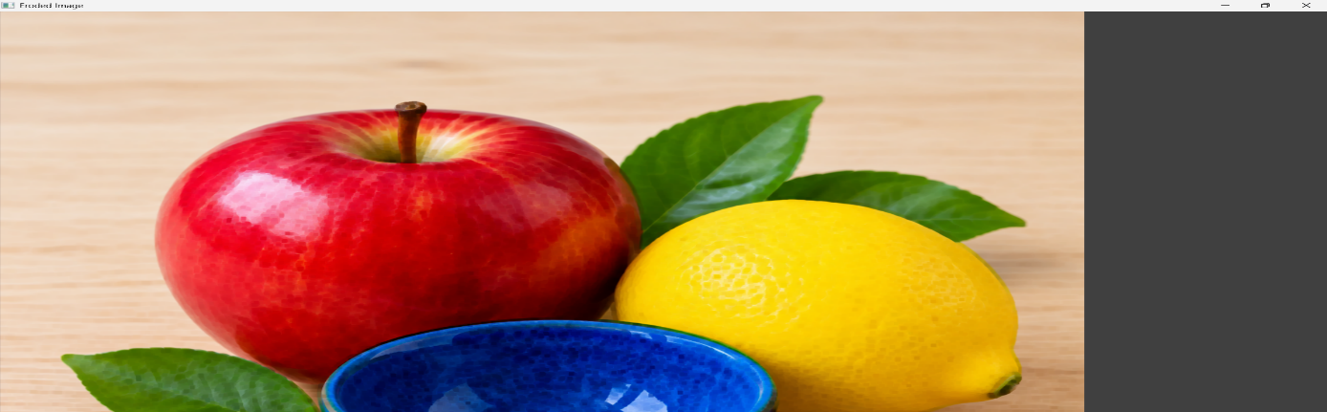

RESULT
Thus, basic image handling and processing operations were performed successfully using Python and OpenCV with the Erode function.

